# **Reflection Template 2**

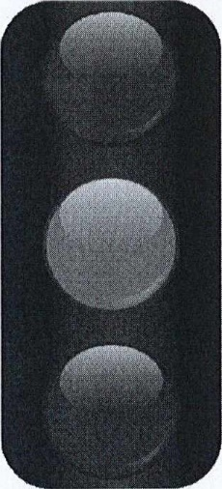

|  |
| --- |
| 1-2 things I should STOP doing:  1-2 things I should CONTINUE doing:   * 1. things I should GO and do: |

|  |
| --- |
| **My Notes:** |